Choice Family Health Care

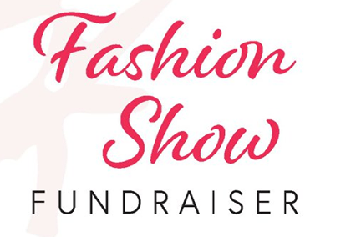
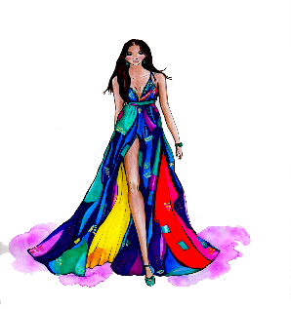

Friday, September 16th, 2022
Riverside Golf Club Grand Island, NE

Cocktails ■ Dinner ■ Fashion Show ■ Live Auction

Choice Family Health Care (CFHC) is a non-profit, public health clinic that specializes in reproductive health care for all. We offer affordable access to many services including well woman exams, breast cancer screening, STD/HIV testing, pregnancy testing and contraception at reduced or no cost to those eligible. We also provide health education and outreach within the communities we serve.

Individual tickets: $50- includes dinner, the fashion show, live auction and a wine glass.

Corporate Table: $500 & $600- includes dinner, the fashion show, live auction and wine glasses.
Choose between the standard corporate table of 8 ($500) or…
Choose a table of 8 close to the runway to feel like you are part of show! ($600) We will even include 2 bottles of wine and wine glasses.

Our models will be walking the runway in the latest fashions from West Anna Boutique. There will be a pop-up boutique set up for your shopping pleasure along with a live auction to end the night!

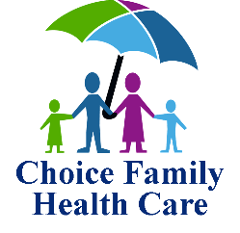
See how you can support the event on the back

---------------------------------------------------------------------------------------------------------------------------------------

How to Support our Event

2022 Choice Family Health Care Fashion Show Fundraiser

Organization: Contact Person:

Address: Phone: Email:

City: State: Zip:

Yes, we would like a corporate table for 8. Please circle: $500 or $600

Yes, we would like to purchase #______ tickets at $50/each

We will be unable to attend the event, but would like to make a donation in the amount of $___________

I would like to provide a donated item for the auction or would like to sponsor an auction item:
Item or $ amount: _____________________

Please feel free to contact us at (308) 384-7625
or
return this form to:

Choice Family Health Care
217 E. Stolley Park Rd. Ste E
Grand Island, NE 68801

